Methodical instructions to laboratory work 4

STUDY OF MATRIX COMPUTER SYSTEMS

Purpose of work. Analysis of functionality and efficiency of matrix computer systems.

General information
Matrix systems belong to SIMD(single instruction, multiple data ) class.
We consider general structures of matrix systems. First of them (fig.1) consists of n processor elements (PE), interconnection network and program (instruction) memory. PE includes processor and local data memory. Today is more usefull another general structure (fig.2). It differs from first one by presence scalar processor and its local memory. This processor can be used for scalar operations.
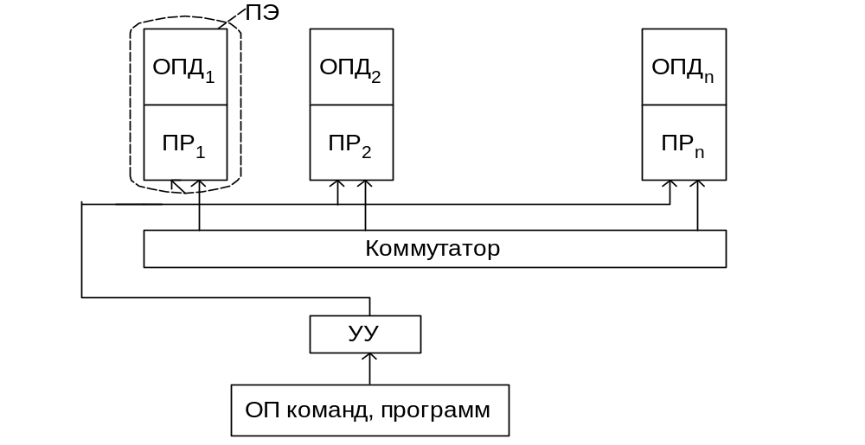

Fig.1. General structure of Matrix system without scalar processor
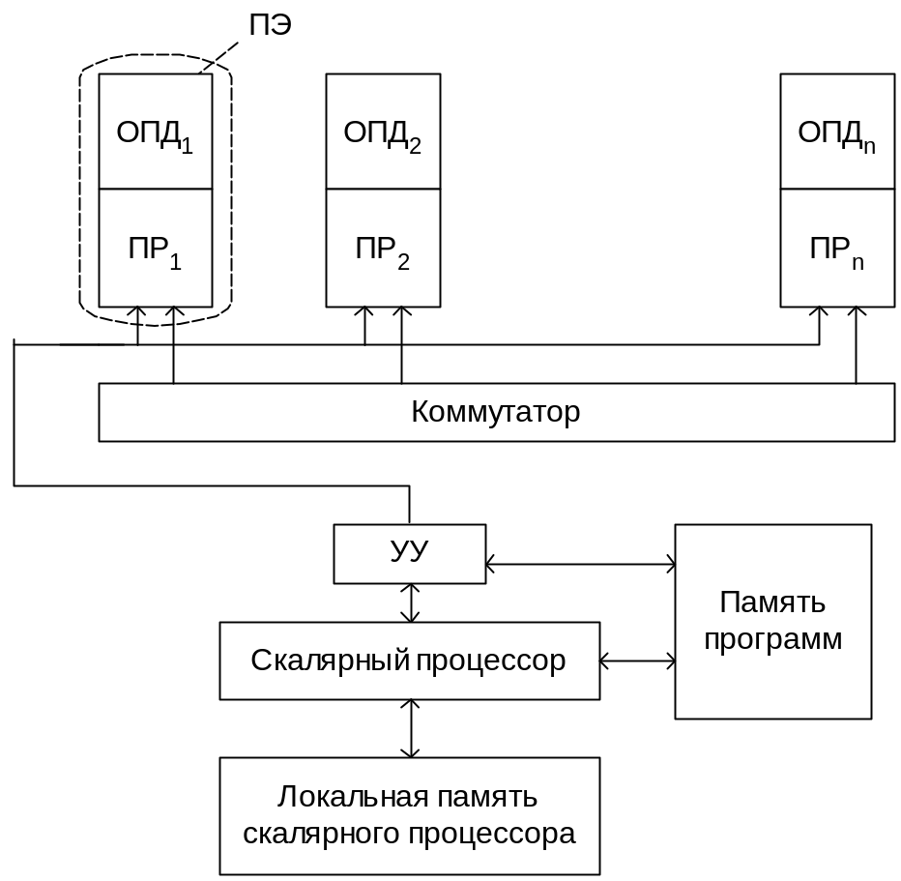

Fig.2. General structure of Matrix system with scalar processor

The main advantage of matrix systems is in structure simplicity. They have the highest ratio (соотношение) of application performance to system cost for tasks with natural concurrency (параллелизм) such as matrix and vector operations, linear and differential equation systems solving and so on.
Disadvantages of matrix systems are in following:
- Mismatching(несовпадение) of task and system dimensions(размеры).
- Tasks can include sequence(ряд) of vector and scalar operations. During scalar operation solving in scalar processor set of PE don’t work.
- Interconnection network can be static or dynamic. Static connections have some troubles as to effective organizations of data transfer. The best way of dynamic connection is in using of crossbar switches. They allow the highest speed of processor communications. But they are very expensive. Their cost is proportional to processors number.
- Performance degradation because of algorithm branching. Result of conditional branch operator is choosing one of the branches to solving. So, processor elements for solving another branch are in time-out. Therefore with growth of matrix system processors (n) performance increases non linear and proportional to value log2n (fig.3).
- 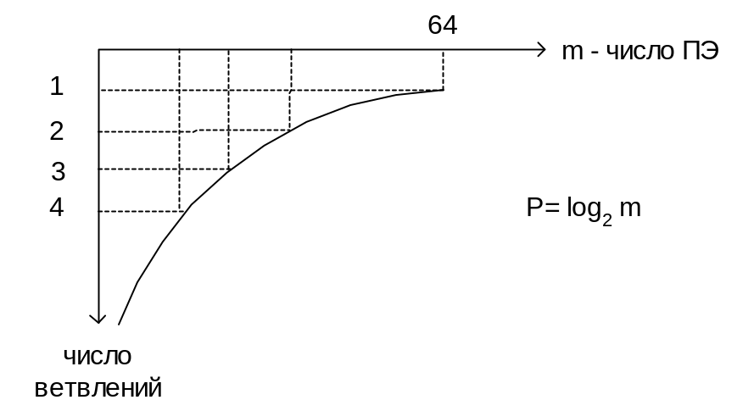Great troubles connected with preparation of tasks to solving in matrix systems (at the same tine it is possible to solve only identical operations). An example of this preparation you can see on fig.4.

Fig.3 Dependence performance value on branches number in Matrix system

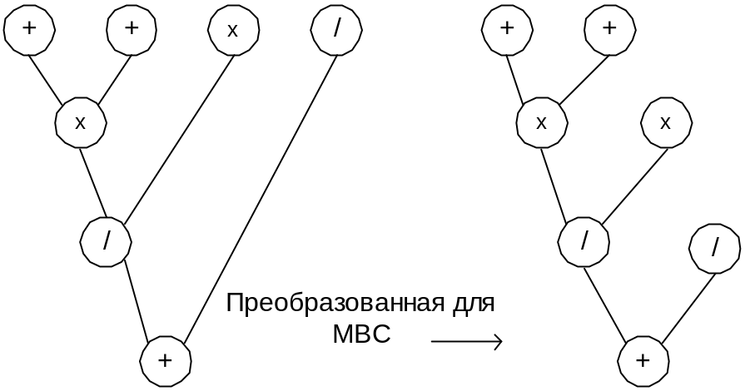

Fig.4 Preparation parallel tree for solving in matrix system.

We will consider the following efficiency measures:
- Speedup (S). It determines by following formula: 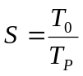 where T₀ solution time of application on the single processor and T_{p} solution time of application on the parallel system. The values of S are changing in the following range: 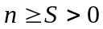 If S<1 then we have speed down. If S=1 then we have no speedup. If S>1 then we have speedup.
- Application efficiency (E_{a}). It defines as a ratio of speedup to the number of processors.
In an ideal parallel system speedup is equal to n and application efficiency equals to 1.

Laboratory work task
Initial data:

- Arithmetic expression (таbl.1);
- coef. α and β values (таbl.1)

Task is in following:

- Create parallel graph (tree) for arithmetic expression where nodes are solving arithmetic operations and edges are connections between dependent operations;
- Perform preparation of parallel tree for matrix solving where only single arithmetic operations belong to the same level;
3) Determine value of Т_{о} (in tact’s) for every arithmetic operation, if t₊=1 tact; t*= * t₊, t/=*t₊;
4) Perform optimal assigning (scheduling) operations on processors of Matrix system with various numbers of processors (from 2 up to graph width). Use program simulation PLASMA;
4) Determine execution time, speedup and application efficiency for various numbers of Matrix system;
5) Choose optimal number processors of Matrix systems for using arithmetic expression and perform analysis results of systems working

Таbl.1
Var. | Arithmetic expression | Coef.  α | Coef.  β
1 | (A+B+C)*(D+G)/E+L*K/F | 2 | 3
2 | A*B+C*D+G*K/(L+H)*E | 3 | 4
3 | (A+B/C*G)*(K+E+L)/R+D | 2 | 4
4 | A*B/C+D*E/(G+K/L)+M | 3 | 5
5 | A+B+C/D+G*(K/L+M+N) | 2 | 5
6 | A+B*(C+D*E*(G+L/K))+N | 2 | 4
7 | A*(B+C/D)+G*K*L+M/N | 4 | 5
8 | A/B+(C+D*E)*(G+K/L*M) | 3 | 5
9 | (A*B+C/D+G*K)(M+N+E) | 2 | 3
10 | A/B+C/D+G*(K+L*(M+N)) | 2 | 4

